Periodontology
Dr.Huda Jasim
Clinical Diagnosis and Examination
(Part 3)
Examination of the Periodontium

-Biofilm and Calculus
There are many methods available for assessing plaque and calculus accumulation. The presence of supragingival plaque and calculus can be directly observed and the amount measured with a calibrated probe. For the detection of subgingival calculus, each tooth surface is carefully checked to the level of the gingival attachment with an explorer, warm air may be used to deflect the gingiva and aid in visualization of the calculus. Although the radiograph may sometimes reveal heavy calculus deposits interproximally and even on the facial and lingual surfaces, it cannot be relied on for the thorough detection of calculus.

-Gingiva
The gingiva must be dried before accurate observations can be made . Light reflection from moist gingiva obscures detail. In addition to visual examination and exploration with instruments, firm but gentle palpation should be used for detecting pathologic alterations in normal resilience, as well as for locating areas of exudate. Features of the gingiva to consider are: color, size, contour, consistency, surface texture, position, ease of bleeding, and pain .Any deviation from the normal should be evaluated and not overlooked.
The distribution of gingival disease and its acute or chronic nature should also be noted. Clinically gingival inflammation can produce two basic types of tissue response: edematous and fibrotic. Edematous tissue response is characterized by a smooth, glossy, soft, red gingiva. In the fibrotic tissue response, some of the characteristics of normalcy persist; the gingiva is more firm, stippled, and opaque, it is usually thicker, and the margin appears rounded.

-Periodontal Pockets
Definition:
It is defined as a pathologically deepened gingival sulcus. It is the most important clinical feature of periodontal disease.
Deepening of the gingival sulcus may occur by: - Coronal movement of gingival margin, Apical displacement of the gingival attachment, Combination of the 2 processes
Classification:
1. Gingival Pocket-(Pseudopocket)Formed by gingival enlargement without destruction of the underlying periodontal tissue. The sulcus is deepened because of the increased bulk of the gingiva.
2. True Pocket-(Periodontal Pocket) Occurs with destruction of supporting periodontal tissues. This can be further classified as:
Two types of true periodontal pockets exist according to relationship of the base of the pocket to the crest of the alveolar bone, as follows:
-Suprabony (supracrestal or supraalveolar) occurs when the bottom of the pocket is coronal to the underlying alveolar bone.
-Intrabony (infrabony, subcrestal, or intraalveolar) occurs when the bottom of the pocket is apical to the level of the adjacent alveolar bone.

Symptoms
- Localized pain or a sensation of pressure after eating gradually diminishes.
- Foul taste in localized areas.
- Tendency to suck material from the interproximal spaces.
- Radiating pain deep in the jaws.
- Feeling of itchiness in the gums.
-Urge to dig a pointed instrument into the gums with relief obtained from the resultant bleeding.
- Complaints that food sticks between the teeth or teeth feel loose or a preference to eat on the other side.

Clinical Features
- Bluish red thickened marginal gingiva.
- A bluish red vertical zone extends from the gingival margin to alveolar mucosa.
-Gingival bleeding and suppuration.
- Tooth mobility and diastema formation.

Detection of Pockets
The only accurate method of detecting and measuring periodontal pockets is careful exploration with a periodontal probe. Pockets are not detected by radiographic examination. The periodontal pocket is a soft tissue change. Radiographs indicate areas of bone loss in which pockets may be suspected, but they do not show pocket presence or depth and consequently they show no difference before and after pocket elimination unless bone has been modified. Gutta percha points or calibrated silver points can be used with the radiograph to assist in determining the level of attachment of periodontal pockets.

Pocket Probing
Probe penetration can vary depending on:
- The force of introduction,
- The shape and size of the probe tip,
- The direction of penetration,
- Resistance of the tissues,
- Convexity of the crown,
- The degree of tissue inflammation.
In human periodontal pockets, the probe tip penetrates to the most coronal intact fibers of the connective tissue attachment.
-The presence of interdental craters and furcation involvements
To detect an interdental crater, the probe should be placed obliquely from both the facial and lingual surfaces so as to explore the deepest point of the pocket located beneath the contact point
In multirooted teeth, the possibility of furcation involvement should be carefully explored. The use of specially designed probes (e.g., Nabers probe) allows an easier and more accurate exploration of the horizontal component of furcation lesions.

-Level of Attachment versus Pocket Depth
Pocket depth is the distance between the base of the pocket and the gingival margin. It may change from time to time even in untreated periodontal disease because of changes in the position of the gingival margin, and therefore it may be unrelated to the existing attachment of the tooth. The level of attachment, on the other hand, is the distance between the base of the pocket and a fixed point on the crown such as the cementoenamel junction (CEJ). Changes in the level of attachment can be the result of gain or loss of attachment and afford a better indication of the degree of periodontal destruction (or gain).

-Determining the Level of Attachment
-When the gingival margin is located on the anatomic crown, the level of attachment is determined by subtracting from the depth of the pocket the distance from the gingival margin to the CEJ. If both are the same, the loss of attachment is zero.
-When the gingival margin coincides with the CEJ, the loss of attachment equals the pocket depth.
-When the gingival margin is located apical to the CEJ, the loss of attachment is greater than the pocket depth. Therefore the distance between the CEJ and the gingival margin should be added to the pocket depth.

-Bleeding on Probing
The insertion of a probe to the bottom of the pocket elicits bleeding if the gingiva is inflamed and the pocket epithelium is atrophic or ulcerated. Non-inflamed sites rarely bleed. In most cases, bleeding on probing is an earlier sign of inflammation than gingival color changes. However, color changes may present without bleeding on probing.
To test for bleeding after probing, the probe is carefully introduced to the bottom of the pocket and gently moved laterally along the pocket wall. Sometimes bleeding appears immediately after removal of the probe; other times it may be delayed for a few seconds. Therefore the clinician should recheck for bleeding 30 to 60 seconds after probing.
As a single test, bleeding on probing is not a good predictor of progressive attachment loss; however, its absence is an excellent predictor of periodontal stability. When bleeding is present in multiple sites of advanced disease, bleeding on probing is a good indicator of progressive attachment loss.

-Determination of Disease Activity
Currently, there are no accurate methods to determine activity or inactivity of a lesion. Inactive lesions may show little or no bleeding on probing and minimal amounts of gingival fluid. Active lesions bleed more readily on probing and have large amounts of fluid and exudates although active and non-active sites may show no differences in bleeding on probing, even in patients with aggressive periodontitis.
For the determination of pocket depth or attachment levels to provide information on whether the lesion is in an active or inactive state, measurements taken at different times have to be compared. The precise assessment and comparison of the clinical attachment level (CAL) at different intervals of time can determine whether the attachment is being lost, which indicates that the lesion is active. The precise determination of disease activity will have a direct influence on diagnosis, prognosis, and therapy. The goals of therapy may change, depending on the state of the periodontal lesion.

-Amount of Attached Gingiva
It is important to establish the relation between the bottom of the pocket and the mucogingival line. The width of the attached gingiva is the distance between the mucogingival junction and the projection on the external surface of the bottom of the gingival sulcus or the periodontal pocket. It should not be confused with the width of the keratinized gingiva, because the latter also includes the marginal gingiva.
The width of the attached gingiva is determined by subtracting the sulcus or pocket depth from the total width of the gingiva (gingival margin to mucogingival line). This is done by stretching the lip or cheek to demarcate the mucogingival line while the pocket is being probed .The amount of attached gingiva is generally considered to be insufficient when stretching of the lip or cheek induces movement of the free gingival margin

-Degree of Gingival Recession
During periodontal examination, it is necessary to record the data regarding the amount of gingival recession. This measurement is taken with a periodontal probe from the CEJ to the gingival crest.
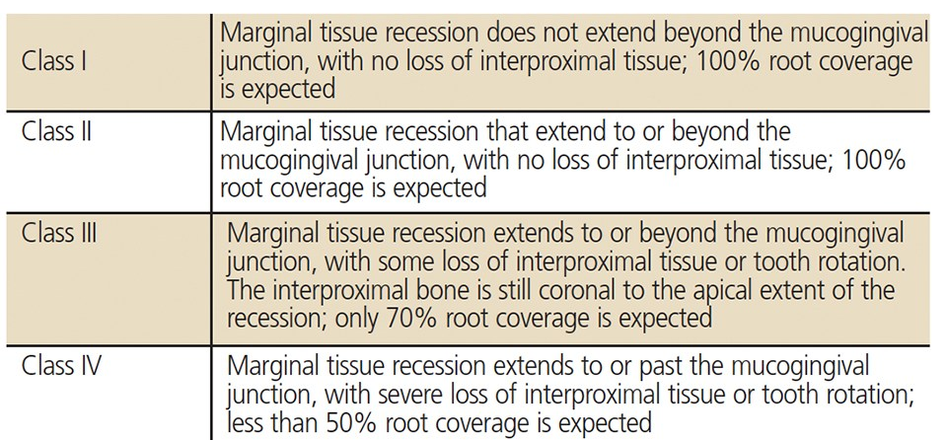

-Periodontal Abscess
A periodontal abscess is a localized accumulation of exudate within the gingival wall of a periodontal pocket. Periodontal abscesses may be acute or chronic.
The acute periodontal abscess appears as an ovoid elevation of the gingiva along the lateral aspect of the root. The gingiva is edematous and red, with a smooth, shiny surface. The shape and consistency of the elevated area vary; the area may be domelike and relatively firm, or pointed and soft. In most cases, exudate may .be expressed from the gingival margin with gentle digital pressure.
The acute periodontal abscess is accompanied by symptoms such as throbbing, radiating pain and tenderness of the gingiva to palpation. Other symptoms may include sensitivity of the tooth to palpation; tooth mobility and lymphadenitis; and less frequently, systemic effects such as fever, leukocytosis, and malaise.
The chronic periodontal abscess usually presents a sinus that opens onto the gingival mucosa along the length of the root. There may be a history of intermittent exudation. The orifice of the sinus may appear as a difficult-to-detect pinpoint opening, which, when probed, reveals a sinus tract leading deep into the periodontium.
The chronic periodontal abscess is usually asymptomatic. However, the patient may report episodes of dull, gnawing pain; slight elevation of the tooth; and a desire to bite down and grind the tooth.
The chronic periodontal abscess often undergoes acute exacerbations, with all the associated symptoms. Diagnosis of the periodontal abscess requires correlation of the history and clinical and radiographic findings.

-Periodontal Abscess and Gingival Abscess
The principal differences between the periodontal abscess and the gingival abscess are location and history.
The gingival abscess is confined to the marginal gingiva, and it often occurs in previously disease-free areas. It is usually an acute inflammatory response to forcing of foreign material into the gingiva. The periodontal abscess involves the supporting periodontal structures and generally occurs in the course of chronic destructive periodontitis.

-Periodontal Abscess and Periapical Abscess
Several characteristics can be used as guidelines in differentiating a periodontal abscess from a periapical abscess.
If the tooth is nonvital, the lesion is most likely periapical. However, a previously nonvital tooth can have a deep periodontal pocket that can abscess. Moreover, a deep periodontal pocket can extend to the apex and cause pulpal involvement and necrosis. An apical abscess may spread along the lateral aspect of the root to the gingival margin. However, when the apex and lateral surface of a root are involved by a single lesion that can be probed directly from the gingival margin, the lesion is more likely to have originated as a periodontal abscess.
Radiographic findings are helpful in differentiating between a periodontal and a periapical lesion. Early acute periodontal and periapical abscesses present no radiographic changes. Clinical findings, such as the presence of extensive caries, pocket formation, lack of tooth vitality, and the existence of continuity between the gingival margin and the abscess area, often prove to be of greater diagnostic value than radiographic appearance.
A draining sinus on the lateral aspect of the root suggests periodontal rather than apical involvement; a sinus from a periapical lesion is more likely to be located further apically. However, sinus location is not conclusive. In many instances, particularly in children, the sinus from a periapical lesion drains on the side of the root rather than at the apex.

“Be yourself; everyone else is already taken.”
Oscar Wilde

